**Kafka setup & Spark setup**

1. **Kafka Setup**

<http://kafka.apache.org/downloads>

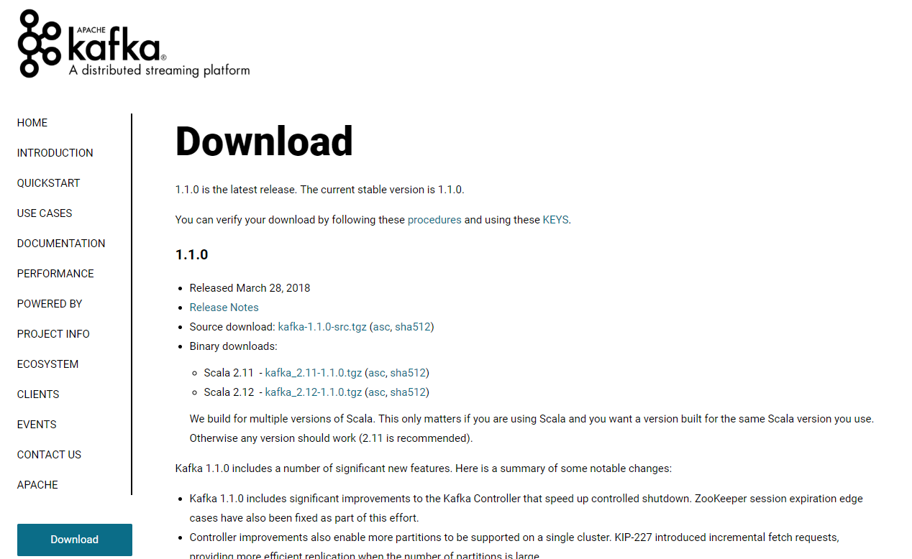

<https://www.apache.org/dyn/closer.cgi?path=/kafka/1.1.0/kafka_2.12-1.1.0.tgz>

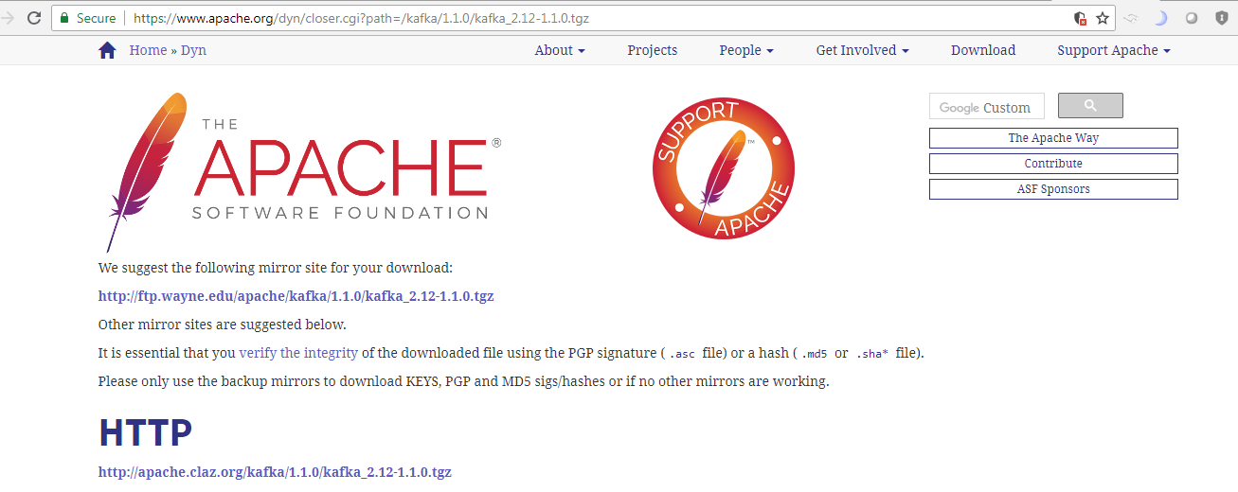

Extract the **kafka_2.12-1.1.0.tgz** file

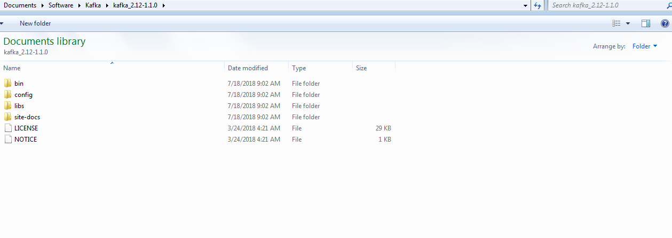

**Kafka commands:**

**Start zookeeper:**

C:\kafka_2.12-0.10.2.1>.\bin\windows\zookeeper-server-start.bat .\config\zookeeper.properties

**Start Kafka:**

C:\kafka_2.12-0.10.2.1>.\bin\windows\kafka-server-start.bat .\config\server.properties

**Create a topic:**

C:\kafka_2.12-0.10.2.1>.\bin\windows\kafka-topics.bat --create --zookeeper localhost:2181 --replication-factor 1 --partitions 1 --topic tweets-topic

**Produce a message:**

C:\kafka_2.12-0.10.2.1>.\bin\windows\kafka-console-producer.bat --broker-list localhost:9092 --topic tweets-topic

>Hello World

**Consume a message:**

C:\kafka_2.12-0.10.2.1>.\bin\windows\kafka-console-consumer.bat --bootstrap-server localhost:9092 --topic tweets-topic --from-beginning

**Spark Setup:**

For Spark , **scala** is required

Ref:

<http://www.eaiesb.com/blogs/?tag=apache-spark-installation-on-windows>

http://nishutayaltech.blogspot.com/2015/04/how-to-run-apache-spark-on-windows7-in.html

**Download scala:**

https://www.scala-lang.org/download/

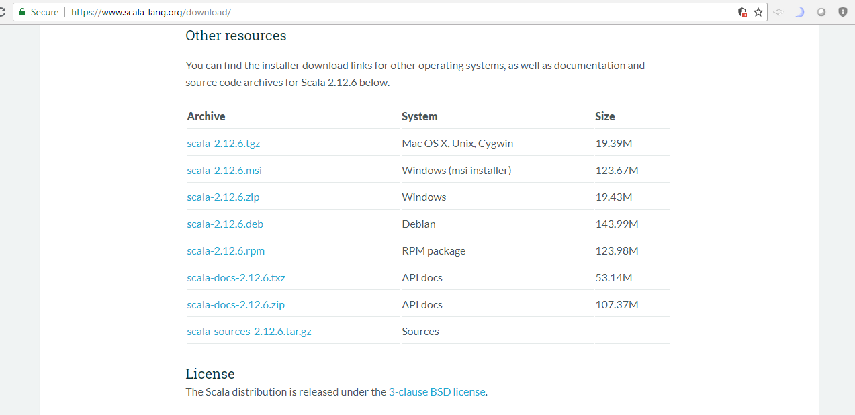

Download SBT:

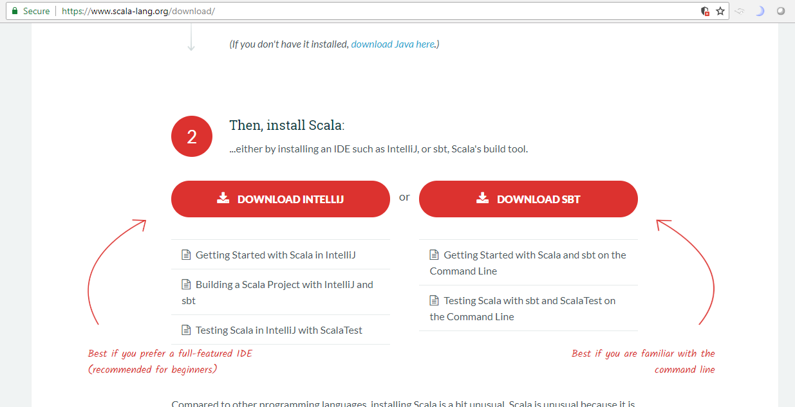

All Platforms ->Download SBT1.1.6.zip

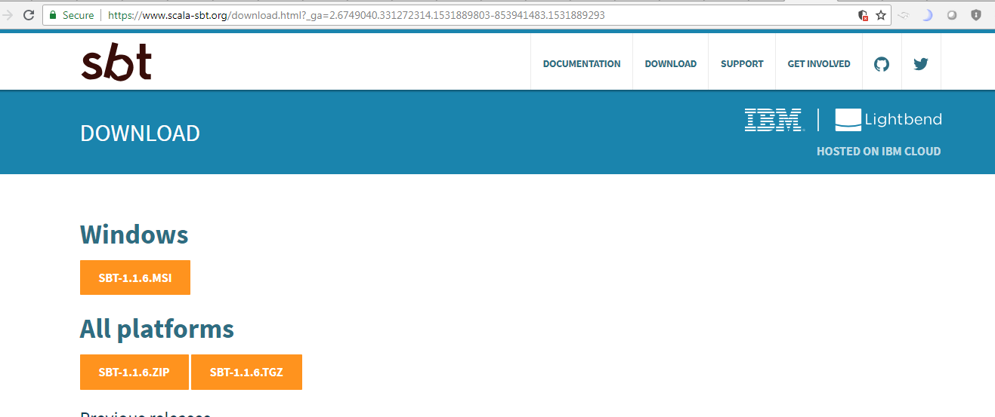

1. Set **JAVA_HOME**

C:\Program Files\Java\jdk1.8.0_91

1. Set **SBT_HOME**

C:\Users\ma143801\Documents\Software\Scala\sbt

1. Set **SCALA_HOME**

C:\Users\ma143801\Documents\Software\Scala\scala-2.12.6

1. Set **SPARK_HOME**

C:\Users\ma143801\Documents\Software\Spark\spark-2.3.1-bin-hadoop2.7

Add in the path:

C:\Program Files\Java\jdk1.8.0_91\bin

C:\Users\ma143801\Documents\Software\Scala\sbt\bin

C:\Users\ma143801\Documents\Software\Scala\scala-2.12.6\bin

C:\Users\ma143801\Documents\Software\Spark\spark-2.3.1-bin-hadoop2.7\bin

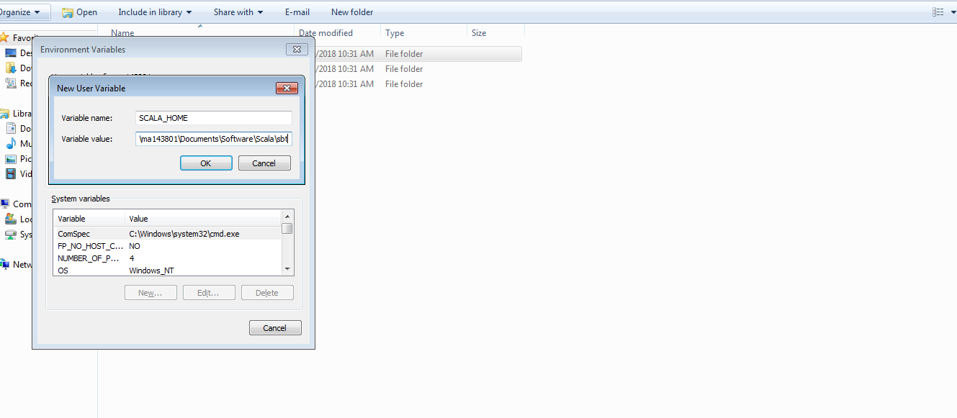



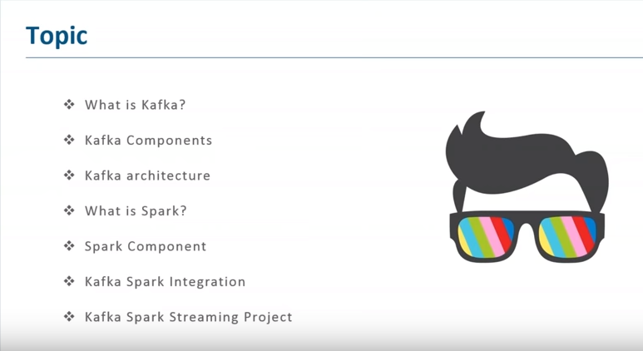

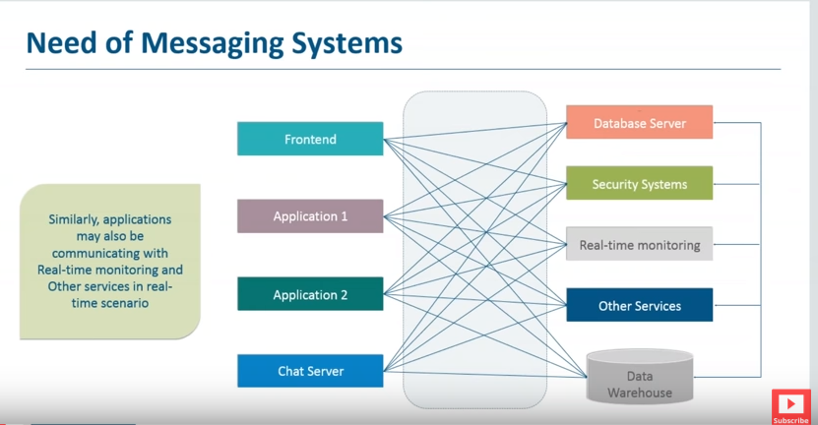

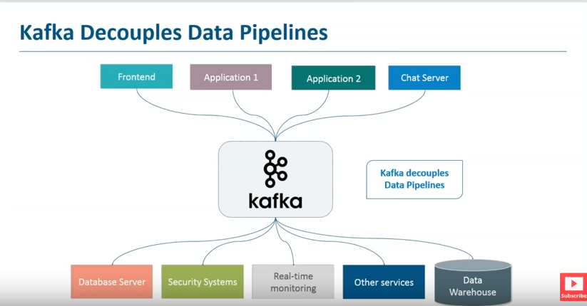

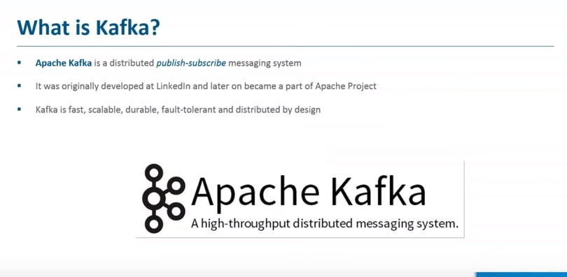

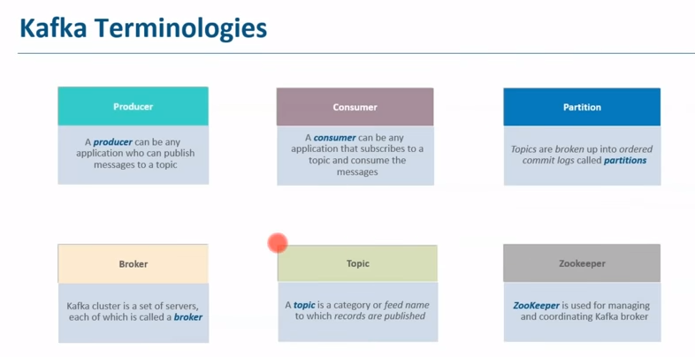

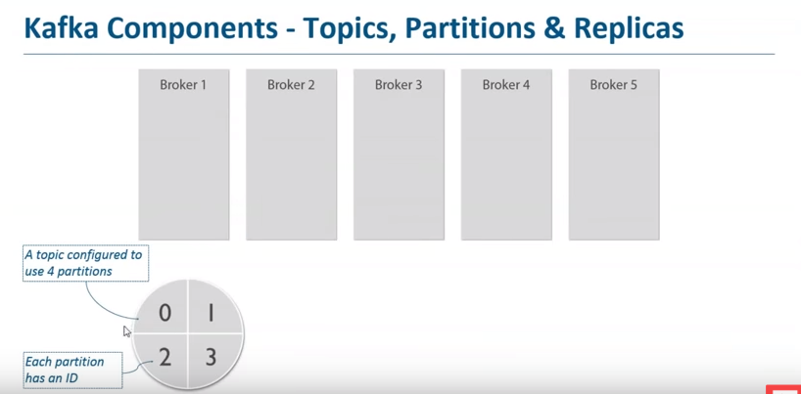

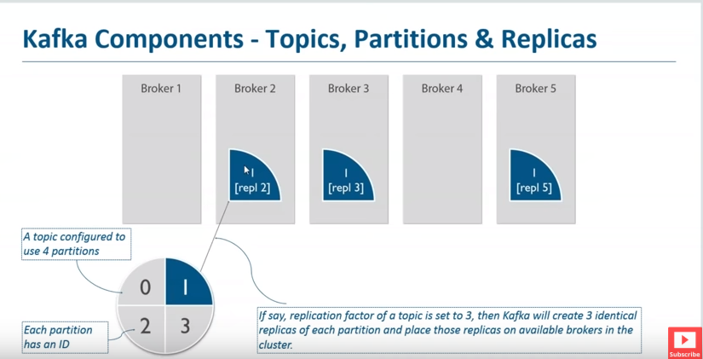

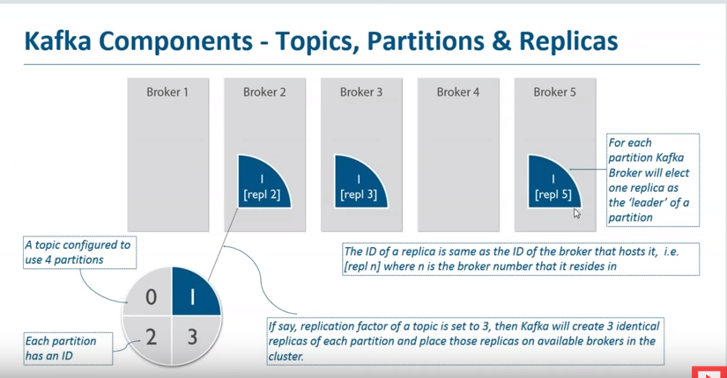

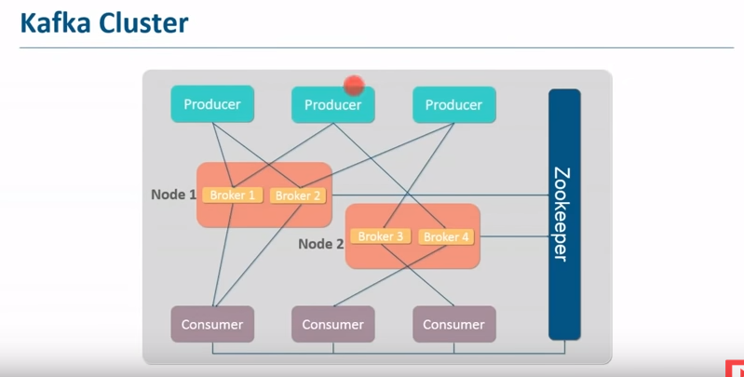



sudo jps

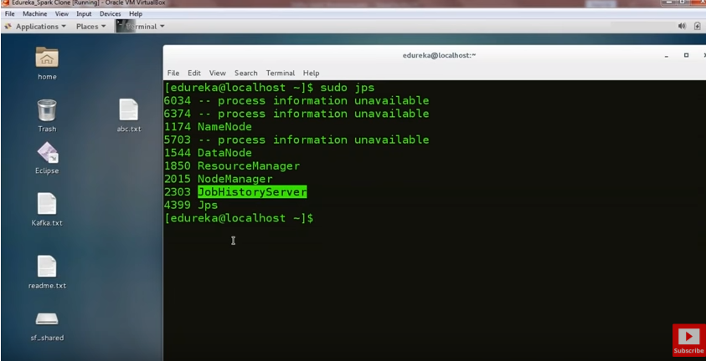

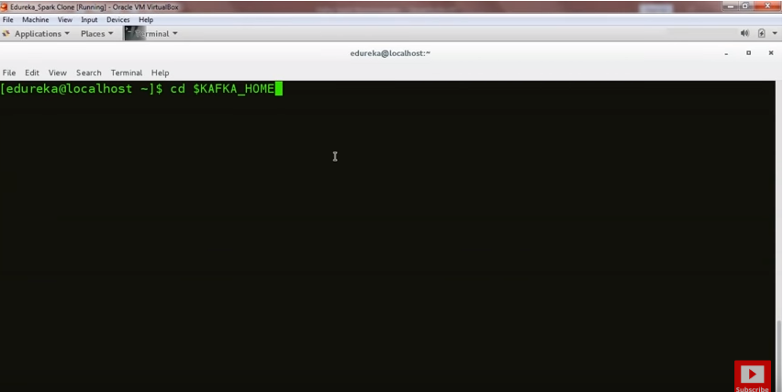

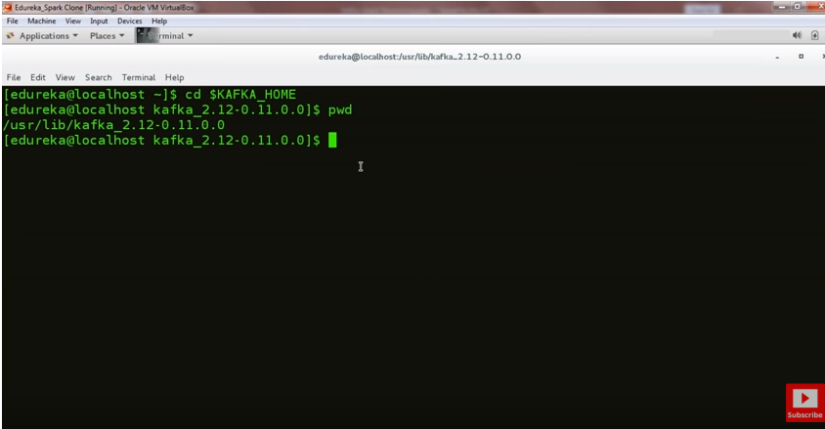

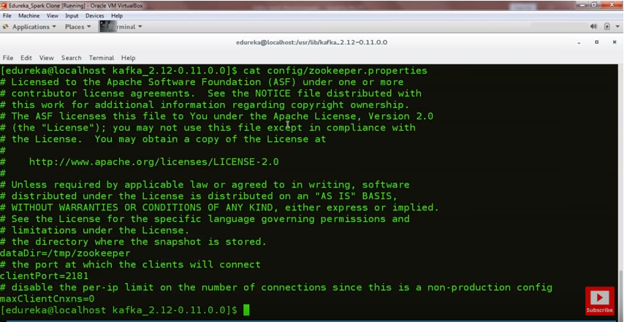

Zookeeper port: 2181

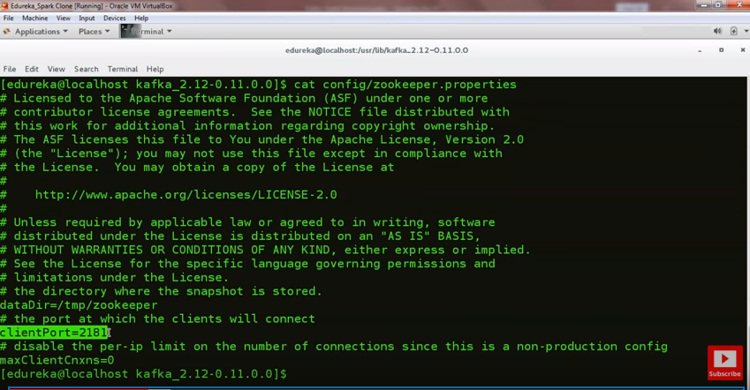

Meta data will be stored in /tmp/zookeeper

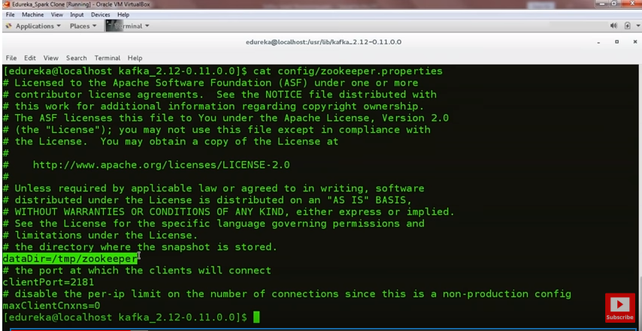

Starting zookeeper:

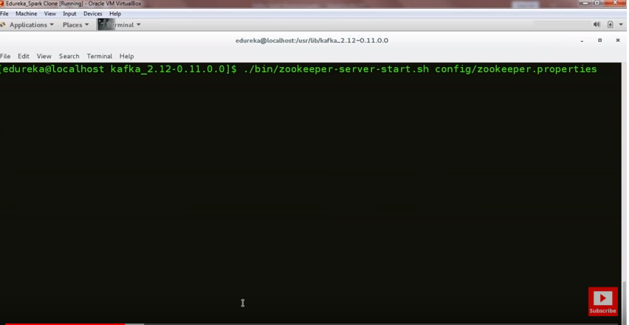

Open another tab:

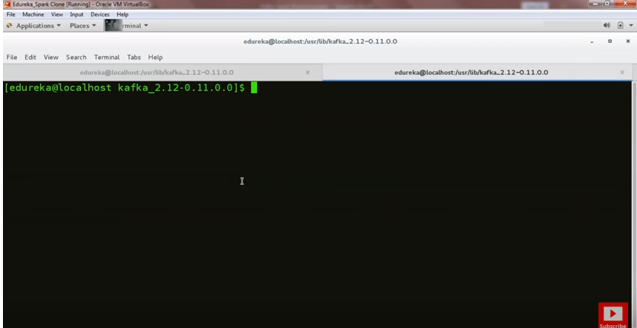

First Kafka broker properties:

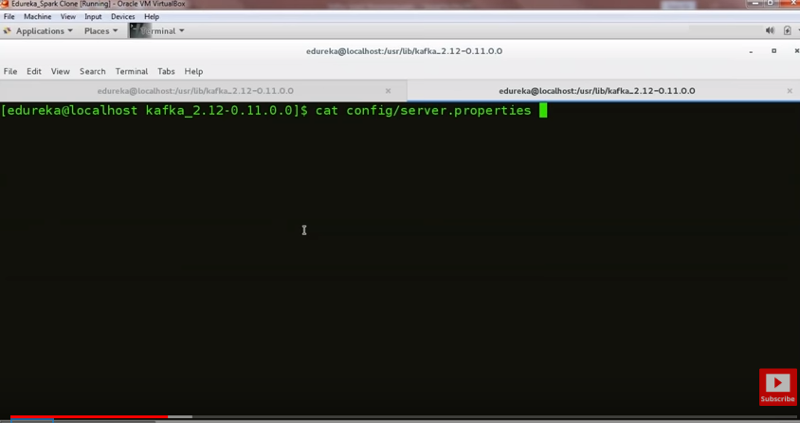

Broker id

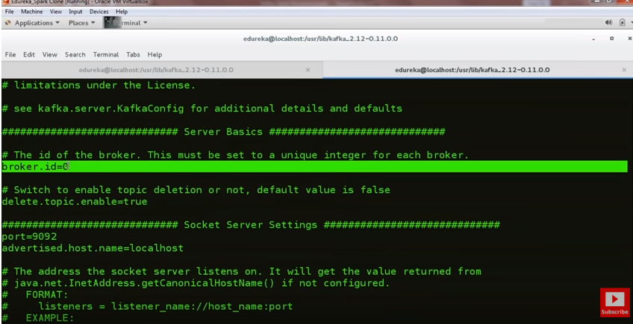

Broker port:

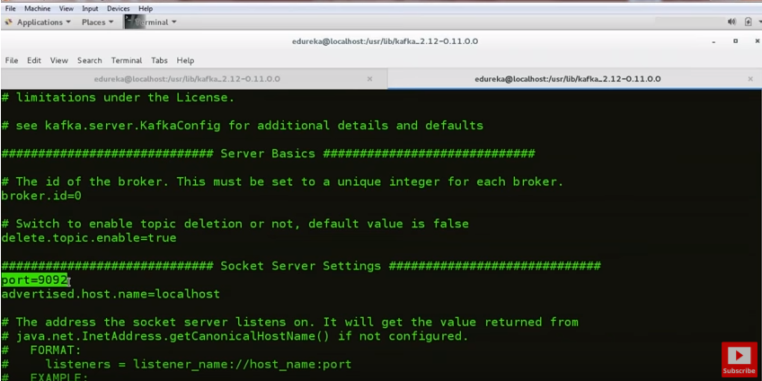

Broker host:

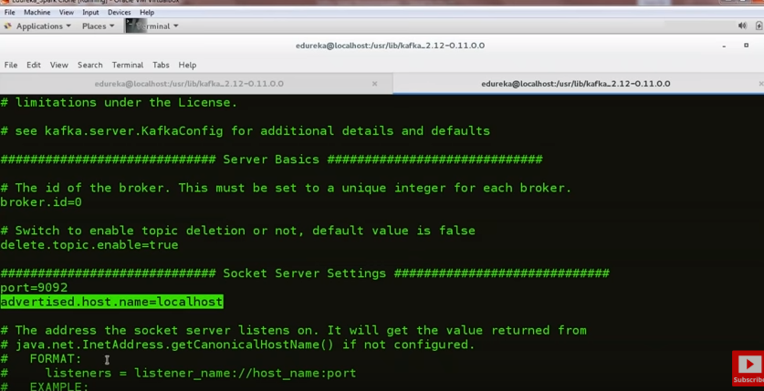

Broker log dir:

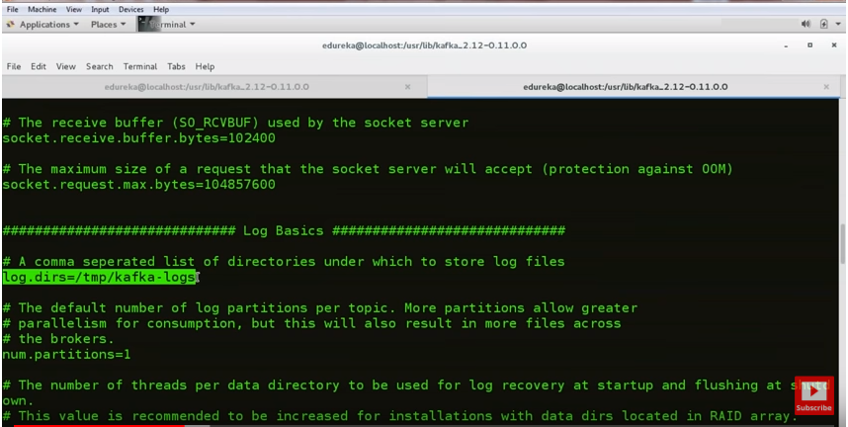

Topic setting:

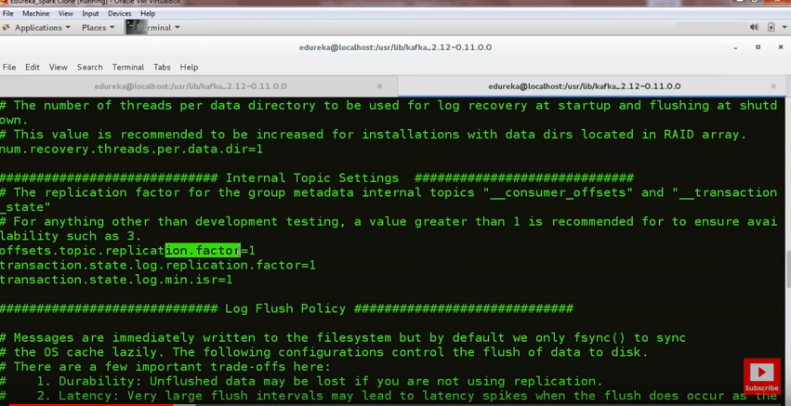

Log retention policy:

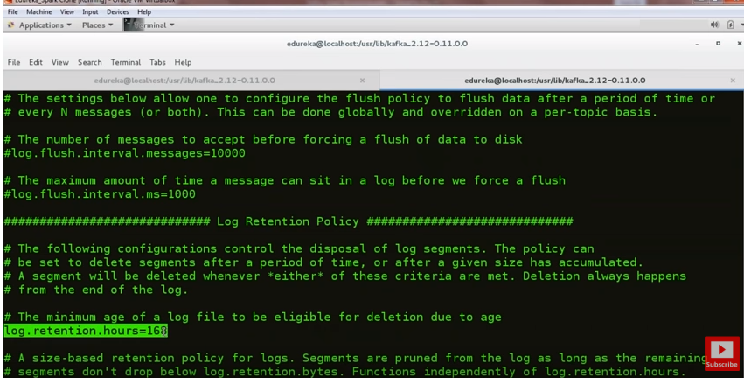

Zookeeper properties:

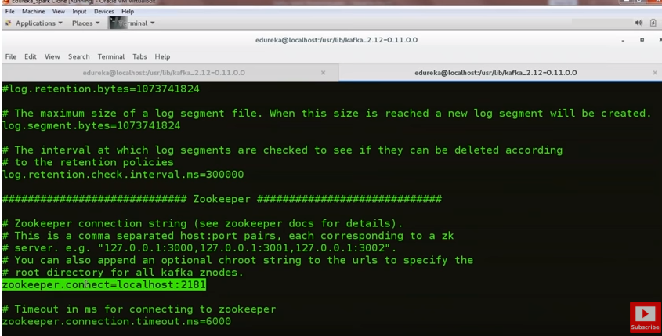

Starting Broker 1:

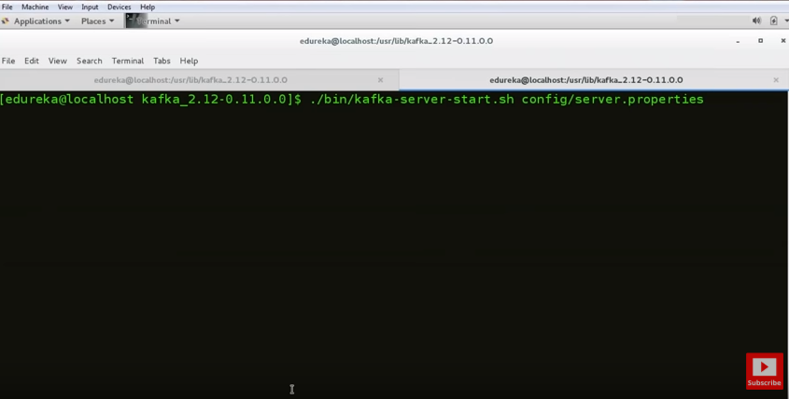

Open another tab:

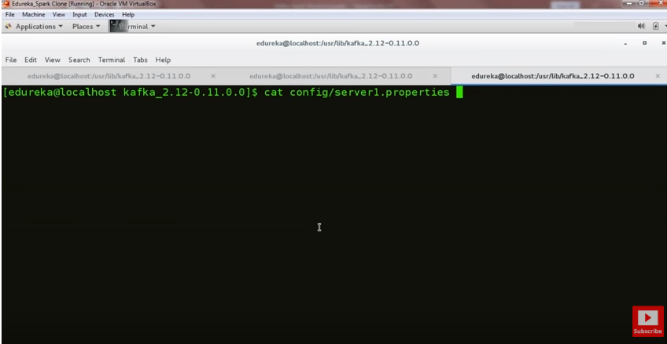

Creating a new broker:

Change broker id:

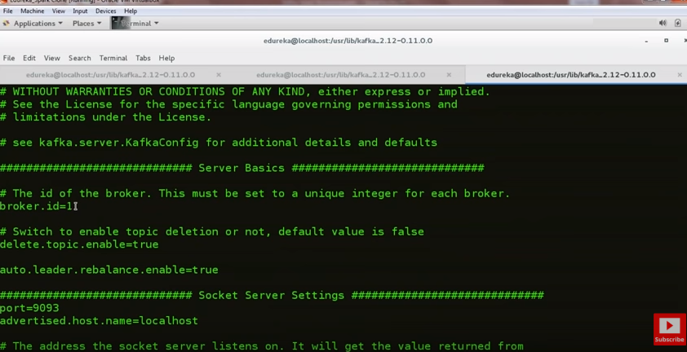

Change port no:

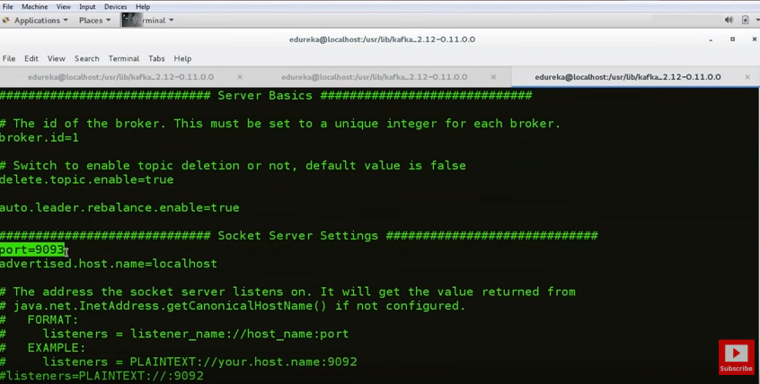

Change log dir:

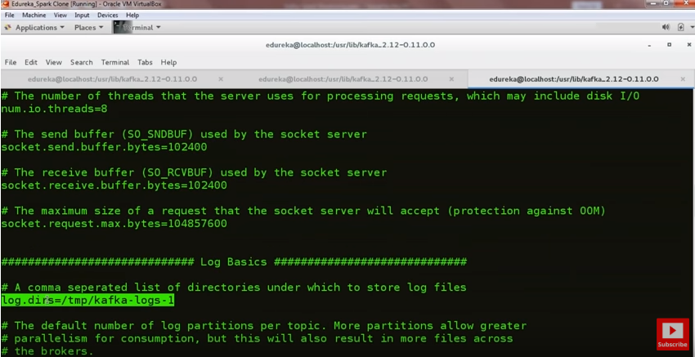

And rest all are same

Starting boker 1:

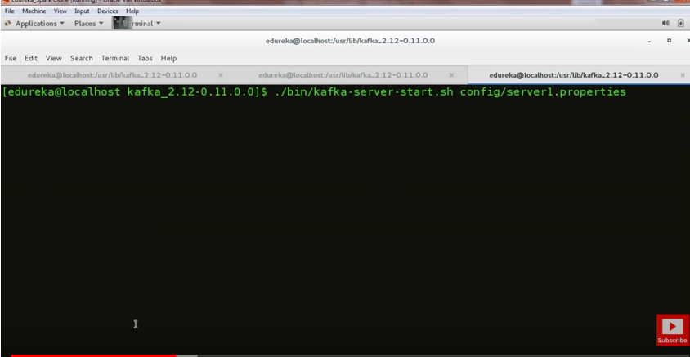

Open another terminal:

Starting broker 2:

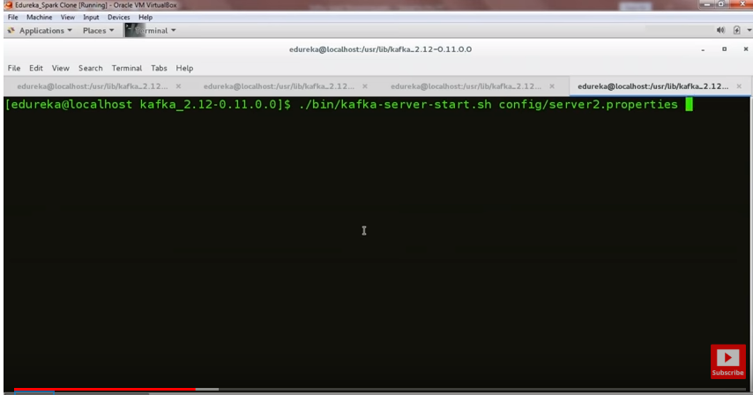

Zookeeper, Broker1, Broke2 is running

Creating a new topic:

Go to kafka home

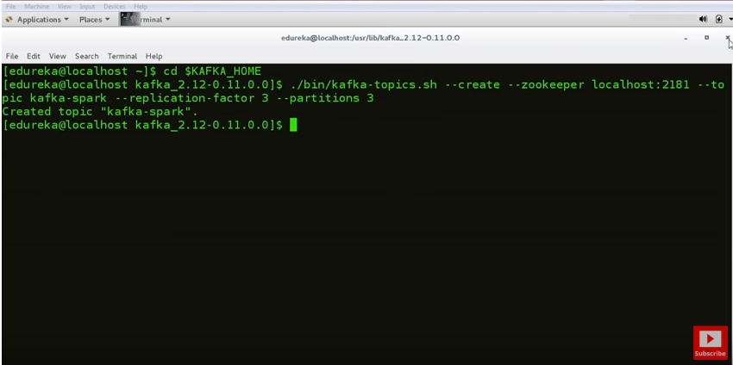

List all the topics:

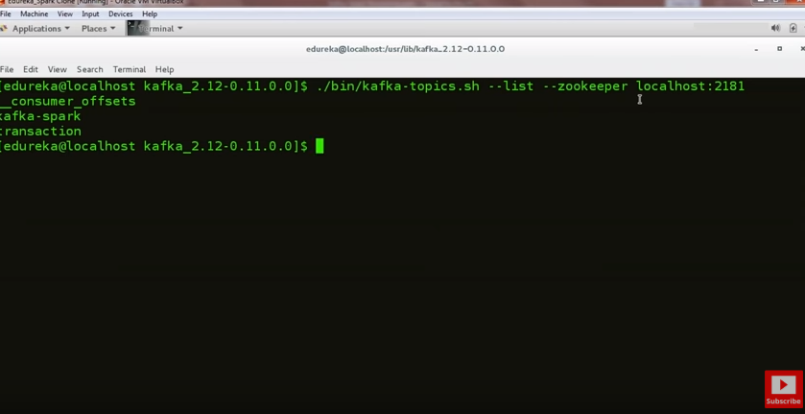

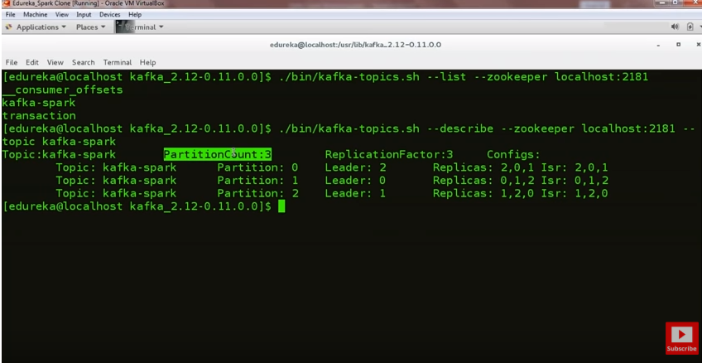

Leader = Broker

Now producing & consuming the message in Kafka

Producer Consumer

